BE ONE OF OUR RESPONSIBLE GUESTS AT SOUTH LYTCHETT MANOR…

You have made a great choice of coming to Dorset – an area of outstanding natural beauty. Let’s keep it this way!

7 things you can do to help save the planet!

- Conserve energy – Reduce energy by switching off heating and lights when not in the caravan and definitely don’t use awning heaters!
We are monitoring our energy levels and we are aiming for an annual 10% reduction.

- Give the car a rest – leave the car behind, if only for a day. Walk, cycle or use public transport.
Why not try our 40 things to do on the number 40 bus. Stop outside the Gates.

- Shop local – use local products, they give you a flavor of the area and help support local communities. We are fortunate to have fantastic producers of food, drink and arts and crafts in our region. See our information centre for local markets.
Try Keatings Butchers meat – its organic, local and stocked in our shop. (local cleaning products)

- Reduce, Reuse, Recycle – try to avoid overly packaged goods and say no to that extra carrier bag. Try and recycle any waste you have.
We have recycling facilities for paper, cans, plastic, glass, gas canisters and batteries, Why not donate your novels to our Telephone Box “Book Swap” for others to enjoy?

- By water wise - We have water saving devices in our toilets.
Why not use water wisely and do not leave taps running when cleaning your teeth!

- Respect nature – Help us to look after the landscape and wildlife by not littering, guarding against fire and using footpaths and cycle-ways responsibly.
Please help use by placing rubbish in bins provided inside and outside the campsite.

- Support Green Tourism Businesses – there are hundreds of businessmen trying to reduce their environmental impacts through the Green Tourism Business Scheme.
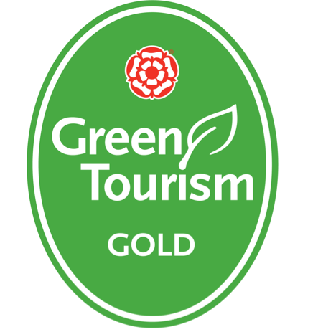
If you feel there is anything else we should be doing to reduce our environmental impact please let us know on your feedback form.

